DWH GoldenGate Installation & Configuration

Contents
1.Introduction 3
2.Prerequisite 3
3.Goldengate software installation 3
4.Configure parameter at db level 6
5.Configure extract & replicat process 9
6.Configure initial load & start extract process 18
7.Start replicat process 19

1.Introduction

This setup will replicate 112 tables from different schemas:
- INSIS_CUST (8 tables)
- INSIS_GEN_BLC_V10 (6 tables)
- INSIS_GEN_CFG_V10 (28 tables)
- INSIS_GEN_V10 (52 tables)
- INSIS_PEOPLE_V10 (6 tables)
- INSIS_SYS_V10 (5 tables)
- INSIS_CPX_V10 (1 tables)
- INSIS_NTW_V10 (6 tables)

2.Prerequisite

- FORCE LOGGING should be enabled
- SUPPLEMENTAL LOG should be enabled
- ENABLE Golden Gate Replication should be true
- Create the necessary tables (only structures) on the Target side.

3.GoldenGate software installation

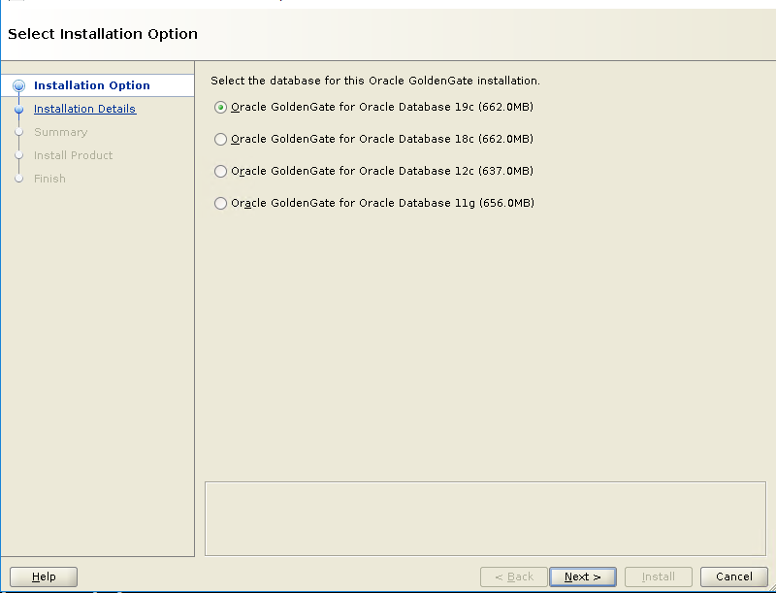

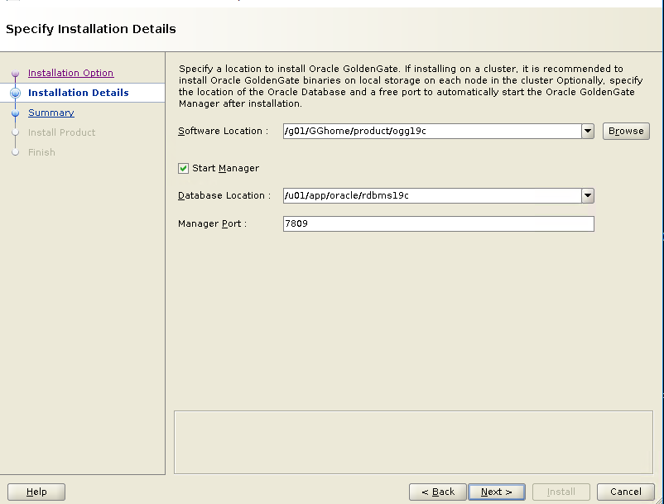
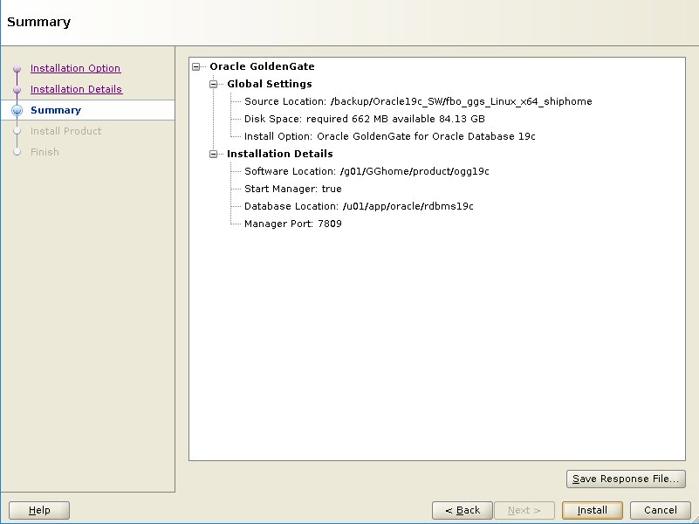
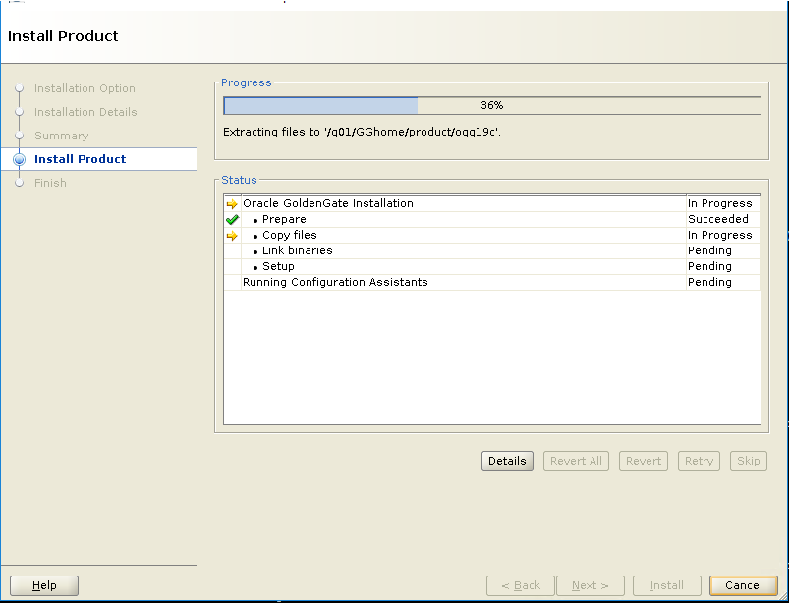
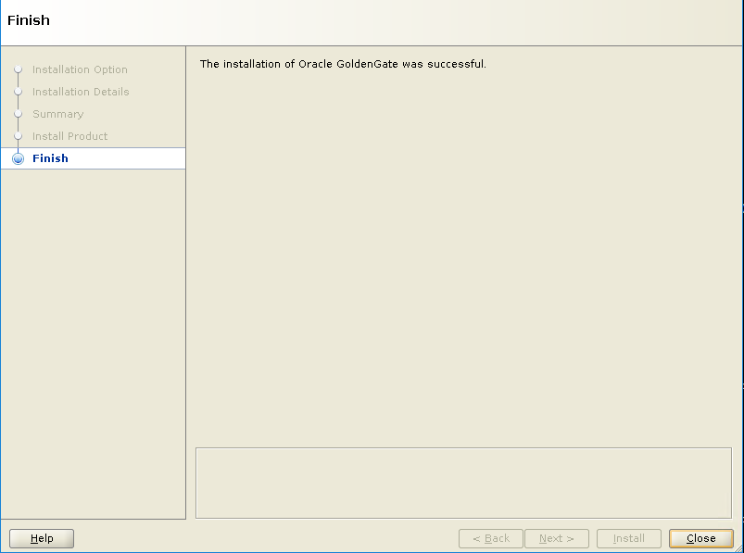

4.CONFIGURE PARAMETER AT DB LEVEL

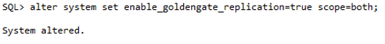
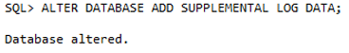
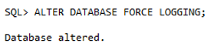
CREATE USERS AND TABLESPACES IN CDB+PDB
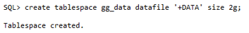
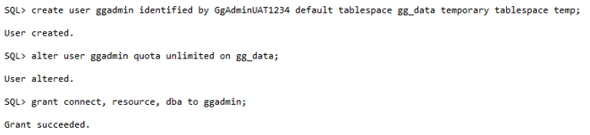
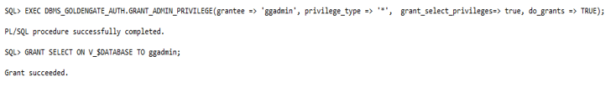
Create User in Container DB (CDB$ROOT)
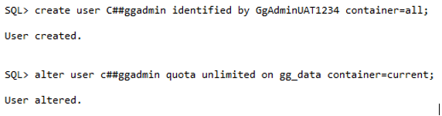
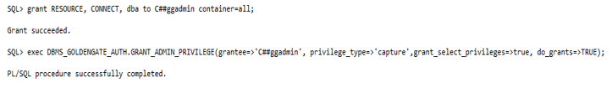
Create Wallet;
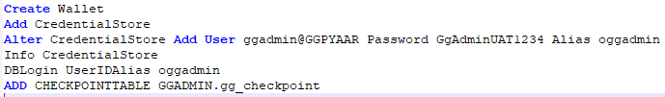
ADD USER C##ggadmin (CDB$ROOT) in GG
Copy Parameter files from working environment:
mgr.prm
INEDW.prm
INRDW.prm

5.Configure extract & replicat process
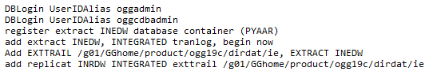
Start only extract, but not replicat
GGSCI> start extract INEDW

6.Perform Initial load

We will perform initial load for INSIS_CUST schema tables. In the same way, we can perform for othe tables.
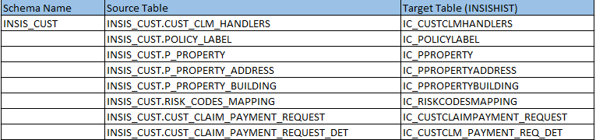
1. CREATE Table structure
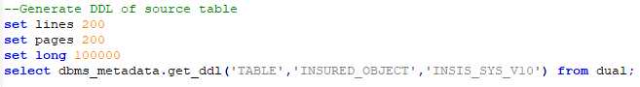
2. Set default value of SRC_COMMIT_TS column in the newly created INSISHIST target table
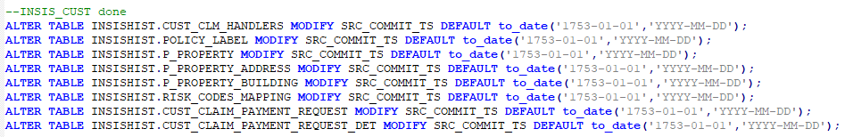
3. Please note the FLASHBACK_SCN value and take data pump export of the source table(s) and import into the target INSISHIST table(s).
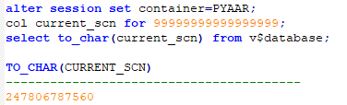

4. Take export:
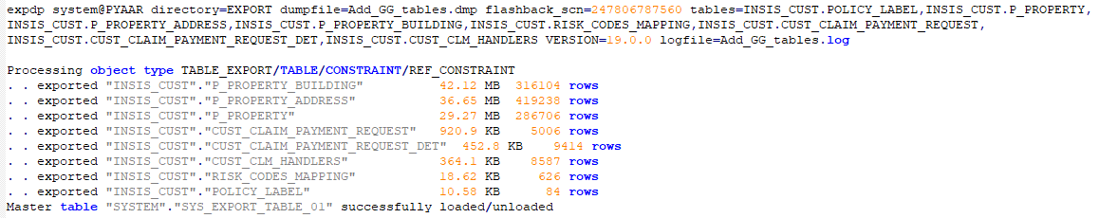
5. Start the import
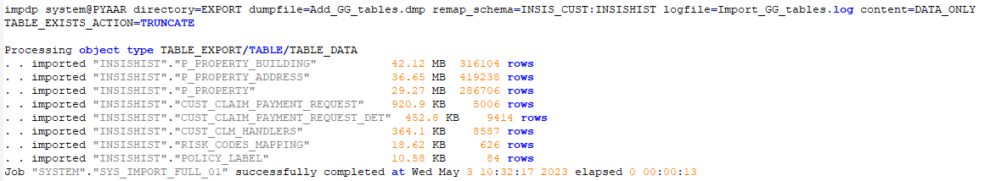
6. Rename the target table name and remove the default value as INSISHIST user.
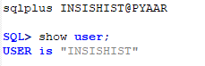
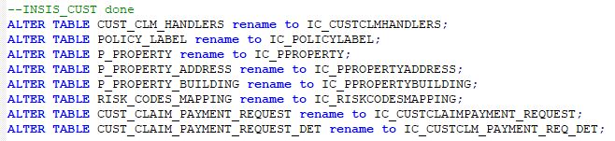
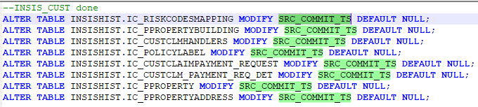

7. start the replic at process

